**SQL Practice PART 02**

**Query 1**

**• Find the name and city of those customers and salesmen who lives in the same city.**

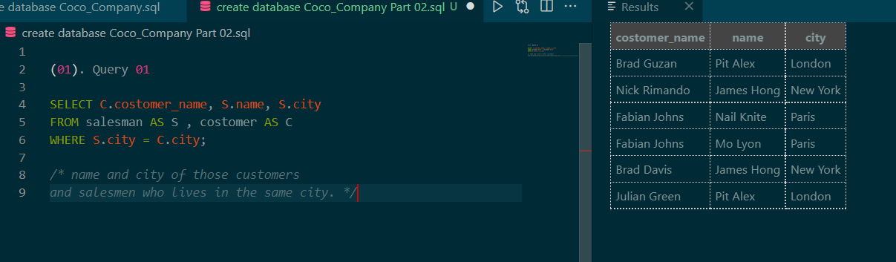

**Query 2**

**• Find the names of all customers along with the salesmen who works for them.**

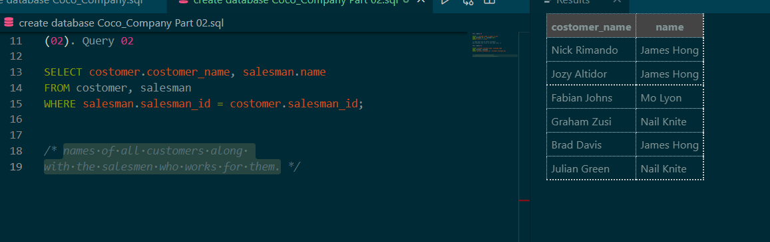

**Query 3**

**• Display all those orders by the customers not located in the same cities where their salesmen live.**

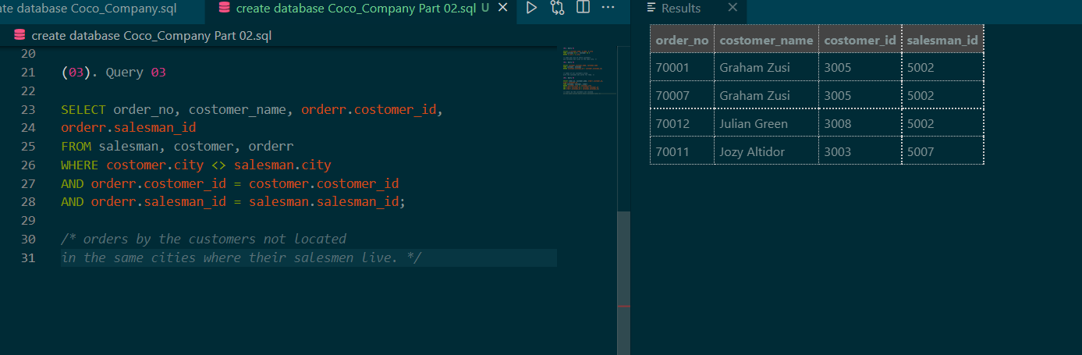

**Query 4 (using subquery)**

* **Display all the orders issued by the salesman 'Paul Adam' from the orders table.**

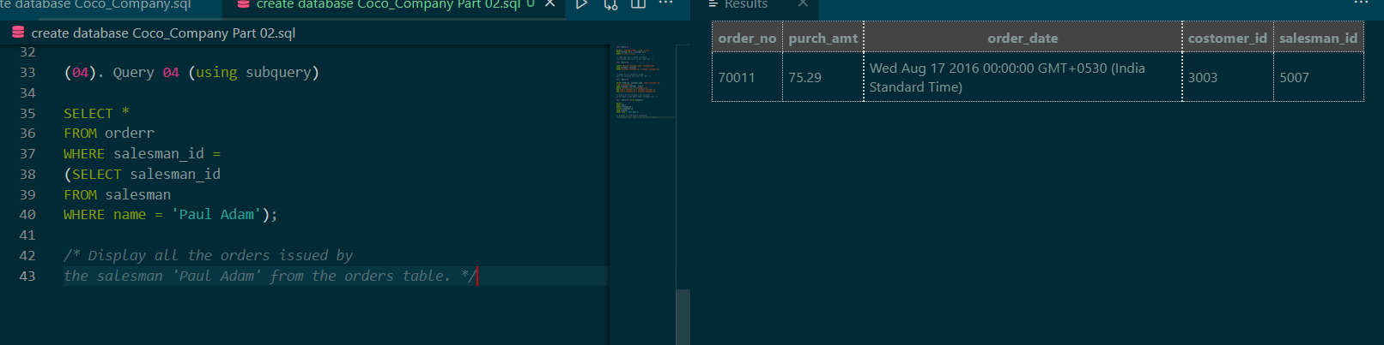

**Query 5 (using subquery)**

**Display all the orders which values are greater than the average order value for 10th October 2012.**

SELECT *

FROM orderr

WHERE purch_amt >

(SELECT AVG(purch_amt)

FROM orderr

WHERE order_date = '2012-10-10');

**Query 6 (using subquery)**

**• Find all orders attributed to salesmen in Paris.**

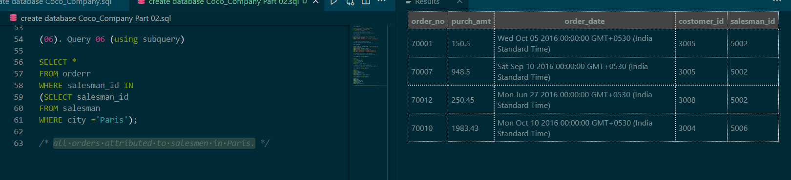

**Query 7 (using subquery)**

**Extract the data from the orders table for the salesman who earned the maximum commission.**

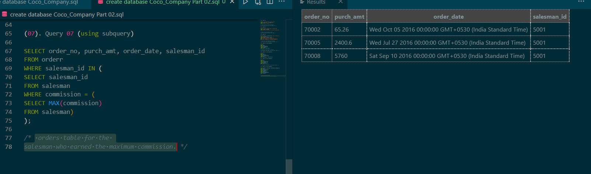

**Query 8 (using subquery)**

**Find the name and ids of all salesmen who had more than one customer**.

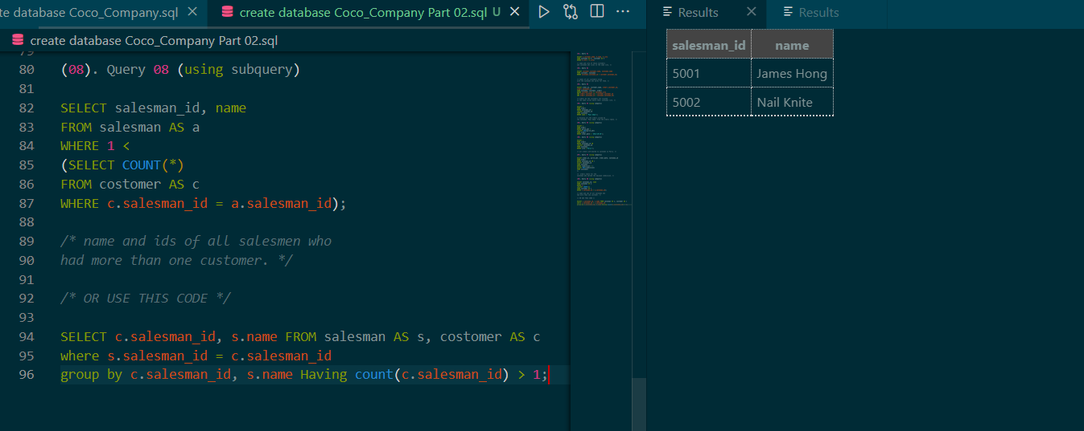

**Query 9 (using subquery)**

**Write a query to find all the salesmen who worked for only one customer.**

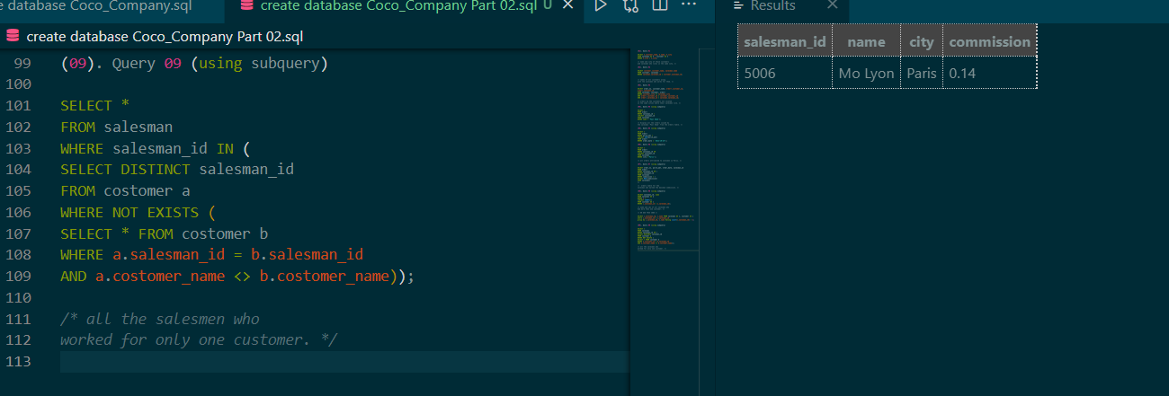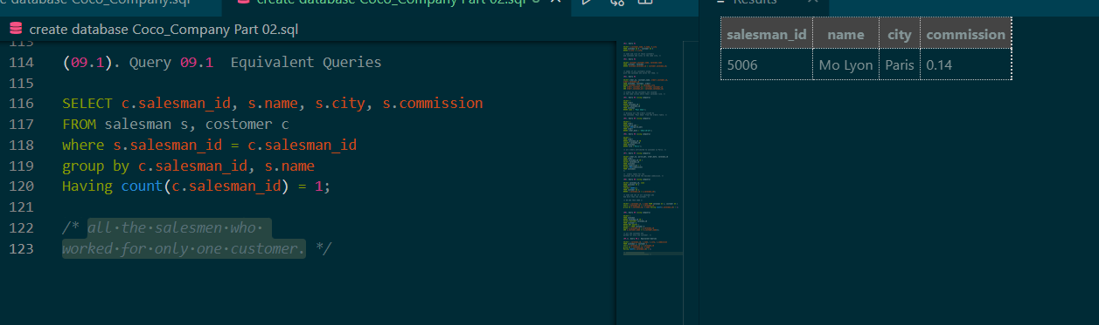

**Query 10 (using subquery)**

**Display all the orders that had amounts that were greater than at least one of the orders from September 10th 2012**

SELECT *

FROM orderr

WHERE purch_amt > ANY

(SELECT purch_amt

FROM orderr

WHERE order_date = '2012-09-10');

**Query 11 (using subquery)**

**display only those customers whose grade are, in fact, higher than every customer in New York.**

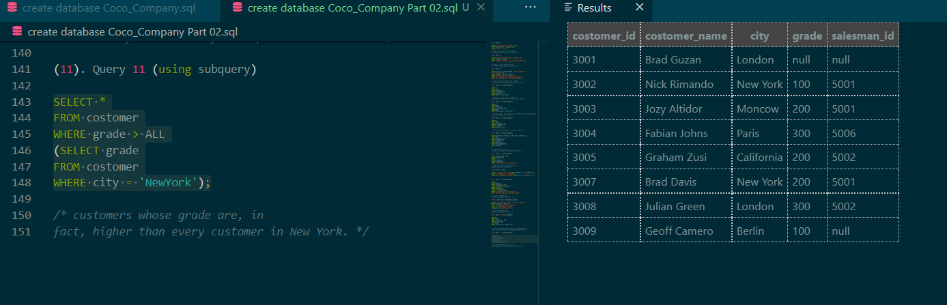

**Use this link to get codes:**

[**https://github.com/DHANUSHKAgitWICKRAMASINGHE/SQL_Practice.git**](https://github.com/DHANUSHKAgitWICKRAMASINGHE/SQL_Practice.git)